BSI.IT.10.C19 – Server Protection – CPA (2026)
IT RCSA – Configuration Management
Item | Detail
Control | BSI.IT.10.C19 – Server Protection (Heracles 50539667)
Risk | [BSI.IT.10.R6 Malicious Software] Systems are compromised due to failure to detect malicious software which may result in unauthorized access to network and data, business and operational disruptions, financial loss, and regulatory noncompliance. (High)
Owner / executor | Ian Rojo
Relevance / nature / frequency | Key Control / Hybrid / In every operation
Testing period | 07/05/2025 – 07/04/2026
Prepared by / reviewer | Edward Morfa (IT RCSA) / Amanda Munoz Henry (Testing Manager)
Evidence | Folder BSI.IT.10.C19 Server Protection/Evidence – files start with their E-number. Screenshots in Evidence/Screenshots.

Control statement
[BSI.IT.10.C19 Server Protection] In every operation and upon imaging of a server, Infrastructure Engineering installs Endpoint Protection on the server to mitigate the risk of any malicious software. Exceptions to disable malware protections on server are approved by the CISO (or delegate).
Status today
Not concluded – Windows design sample passed; Linux population missing

Test script
There is no BSI test script for this control in the 2026 Test Plan. This one follows the SBNA / C10 scripts and the C7 / C8 format, adjusted for BSI. It is also in the testing workbook, tab 2_Test Script.
1. Obtain Evidence
Obtain the CMDB list of Windows and Linux servers built in the period, CrowdStrike (Falcon) host records for them, the BigFix action / image evidence and the Linux build procedure, and any SEF exceptions.
2. Validate Report Completeness and Accuracy
Check the CMDB and Falcon reports (source, filters, run date) and trace a few records to the source. They must show build date, OS and agent status.
3. Validate Population and Scope
Reconcile CMDB servers built in the period to Falcon hosts so no server is left out.
4. Verify Control Execution
Select a sample with the RCSA calculator and check CrowdStrike was installed as part of the build (Windows: image / BigFix action; Linux: manual install).
5. Validate Control Results
Check the sensor is present and active on each sample (Falcon first-seen date close to the build date). Servers without it are deviations unless an exception exists.
6. Verify Exception Handling
For servers without protection, check a SEF exception approved by the CISO or delegate.
7. Verify Escalation and Remediation
Check servers without the agent were ticketed and fixed.
8. Assess Risk Mitigation
Decide whether the install at build plus BigFix keeps every server protected.
9. Summarize Testing Coverage
Record population, samples, results, open items and the conclusion.
Evidence used
Ref | What it is
E01 | Virus and Malware Protection Standard v5.2, approved 05/28/2025 – SUS.VMPS.4.2.3.1-4.2.3.3 (p.7), sec. 6 Exceptions (p.9)
E01a | Same Standard v6.0, approved 07/28/2026 (after the period)
E02 | Linux Red Hat Hardening Guide v3.0 – 4.1 CrowdStrike installed (p.6)
E03 | BigFix screenshot 11/03/2026 – permanent action 00-126993 that installs CrowdStrike on Windows
E04 | Linux CrowdStrike manual install procedure
E05 | CMDB extract 11/04/2026 – 5 rows, all created April 2025
E06 | SEF exceptions approved 07/01/2025 – 07/04/2026 – the file is empty
E07 | Coverage period calculation
E08 | WP2 C19 2025 (prior year)

Testing period
Annual test. The 2025 test covered 10/01/2024 – 07/04/2025, so this one starts 07/05/2025 (Testing Procedure 4.4.2; E07). C19 was rated effective three times in a row (tab 24 Mos). The period ends after the Test Plan window, so the population is pulled through the request date and any rest rolls into the next period (E07 note).
What we did and what we found
1. Evidence obtained
We have the Virus and Malware Protection Standard (E01, E01a), the Linux guide (E02), the BigFix screenshot of 11/03/2026 (E03), the Linux install procedure (E04), a CMDB extract (E05) and the SEF list (E06, empty).
Still missing: the CMDB list of servers built between 07/05/2025 and 07/04/2026, and CrowdStrike (Falcon) records for them.
Result: Partially completed.
Reference: E01-E08
2. Completeness and accuracy
BigFix: console screenshot with date and time (11/03/2026 7:44 PM) and action ID – good.
CMDB: the file has 5 rows, all created 04/03/2025 - 04/15/2025, before the period. It can't be the period population.
Result: Observation – CMDB extract not usable.
Reference: E03; E05 (C19_S3)
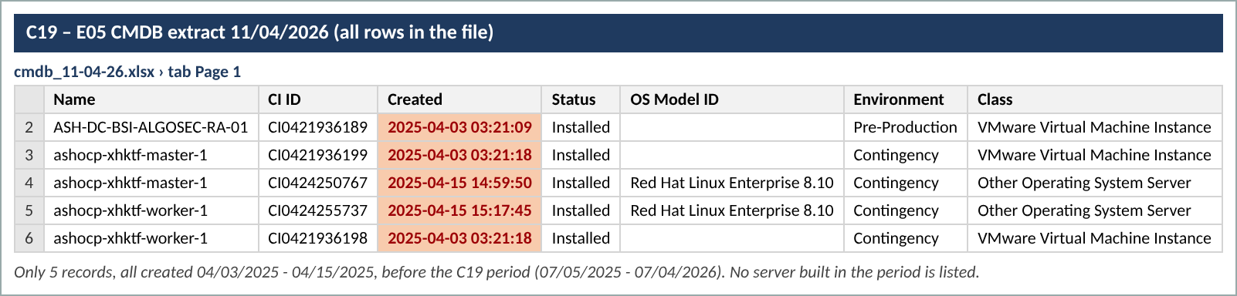
Screenshot 1 – C19_S3_CMDB.png (Evidence/Screenshots)
3. Population and sample
No population of servers built in the period. Last year we tested 1 BigFix configuration and 7 new Linux servers. This year we can test the BigFix configuration only.
Result: Not evidenced – waiting for population.
Reference: E05; E08
4. Windows – BigFix auto-install (A1)
Permanent action 00-126993 is Open, never expires, reapplies without limit and covers Servers Miami, Servers Virginia and Workstations. 100% completed, 25 of 25 applicable computers. The action was issued on 11/19/2024 by MIAYPER (Yamel Perez), who left on 04/10/2026 – observation.
Result: Pass 1/1 (observation on owner).
Reference: E03 (C19_S1, C19_S2)
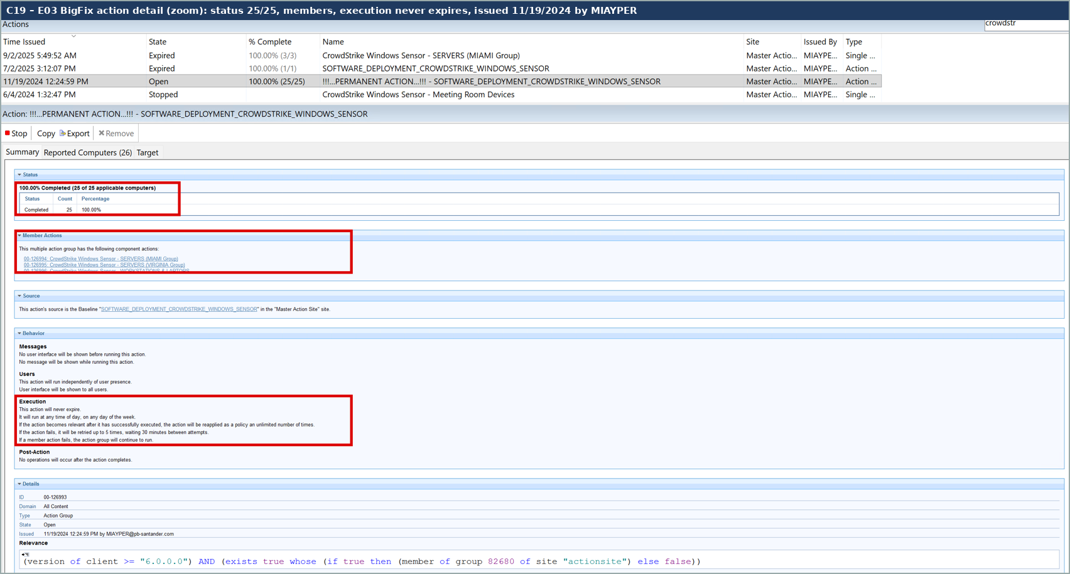
Screenshot 2 – C19_S2_BigFix_zoom.png (Evidence/Screenshots)
5. Linux – agent installed at build (A2)
Can't test – no list of Linux servers built in the period and no Falcon records.
Result: Not evidenced.
Reference: E04; E05
6. Exception handling
No SEF exceptions approved in the period (E06).
Result: Pass – none needed.
Reference: E06
7. Escalation and remediation
No missing agents found in what we could test.
Result: N/A for now.
8. Risk mitigation
Windows servers are covered by the image and a daily BigFix check. Linux coverage for new builds is unknown until the population and Falcon records come in.
Result: Pending.
9. Conclusion
CPA not concluded. If the Linux population and agent records are not received, A2 is not evidenced and the control would be rated Weak.
Result: Not concluded – OI-1 to OI-4.
Sample results
# | Item | Type | What we checked | Value | Evidence | Result
1 | BigFix action 00-126993 | Windows config | Permanent CrowdStrike deploy action | Open; never expires; 25/25 applicable | E03 | Pass
2 | Linux servers built 07/05/2025 - 07/04/2026 | Linux | Falcon installed at build | Population not provided | – | Not evidenced

Open items – what we need to finish
# | What we need | For | What it clears
OI-1 | CMDB report of all Windows and Linux servers created / installed between 07/05/2025 and 07/04/2026 (name, OS, created date, status) with the query used. | Population | Lets us select Linux samples.
OI-2 | Falcon console host list (hostname, first seen, last seen, sensor version) for those servers. | A2 | Proves the agent is installed.
OI-3 | Confirmation who now owns BigFix action 00-126993 (issued by MIAYPER, who left 04/10/2026) and that it still runs. | Observation | Closes the owner observation.
OI-4 | BigFix relevance group for the action – why 25 applicable / 26 reported vs 362 computers in the console. | A1 scope | Confirms no server is outside the action.

Sampling rationale
- Population: servers built in the period – not yet provided (OI-1).
- Windows: one sample of the automated BigFix configuration (Testing Procedure 4.4.3 allows one instance for the automated part). Linux: sample to be set with the RCSA calculator once the population is known.
- 2025 for comparison: 8 samples (1 BigFix configuration, 7 Linux servers).
- Sample sizes: the control runs in every operation (each server build), mitigates a High inherent risk and is Hybrid, so medium assurance applies. For as-needed populations the RCSA sample size calculator prorates the sample on the population (RCSA Testing Procedure 4.4.2, Appendix H). Reference points from the minimum table: 151-250 items = 30, over 250 = 45. If the population is smaller than the sample, test all of it.
- A key attribute that fails fails the sample. For this frequency one exception in the original sample can be followed by an additional sample (Testing Procedure 4.4.8.2 table).

